Experiment 10: Moving (Translating) an Image from One Place to Another
Software / Tools: Python · OpenCV (cv2) · NumPy

AIM
To shift/translate an image from one position to another using an affine translation matrix.
ALGORITHM
1. Import OpenCV and NumPy.
2. Read the input image and note its dimensions.
3. Define horizontal shift (tx) and vertical shift (ty) values.
4. Build a 2x3 translation matrix: [[1,0,tx],[0,1,ty]].
5. Apply cv2.warpAffine() with this matrix to translate the image.
6. Display and save the translated image.
PROGRAM (SOURCE CODE)
import cv2
import numpy as np

img = cv2.imread("image.jpg")
(h, w) = img.shape[:2]

tx, ty = 100, 50 # shift right by 100 px, down by 50 px
M = np.float32([[1, 0, tx], [0, 1, ty]])

translated = cv2.warpAffine(img, M, (w, h))

cv2.imshow("Original", img)
cv2.imshow("Translated", translated)
cv2.waitKey(0)
cv2.destroyAllWindows()

OUTPUT
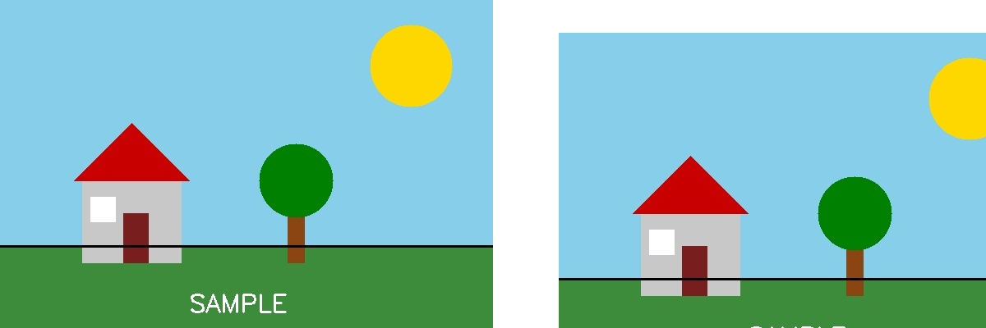
Fig. 10 — Output of Experiment 10: Moving (Translating) an Image from One Place to Another.
RESULT
Shift/translate an image from one position to another using an affine translation matrix — completed successfully, as demonstrated in the output shown above.

